

My SMART Literacy Goal
After testing you and your English teacher will discuss some aspects of either reading or writing that you need to focus on in order to improve.
Year 7 and 8: If you are scoring 4A and above in reading, then your focus would be on forming a writing goal.
Year 9 and 10: If you are scoring 5P/5A and above, then your focus would be on forming a writing goal.
Start of year Literacy GOAL:

What do I need to do to achieve this:

Mid-Year Literacy GOAL: Have I achieved my GOAL? Do I need to set a new GOAL?
New GOAL:

Actions:

End of year Literacy GOAL: Have I Achieved My Goal?

What do I hope to achieve for the rest of the year and into next year?

My SMART Numeracy Goal
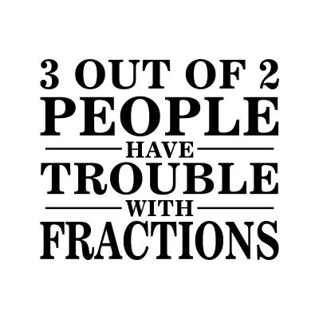



Set a SMART goal based on the outcomes of the tests* you have done in Term 1. Your Mathematics teacher will help you.
*Year 7 and 8: Number Knowledge or Number Operations
*Year 9 and 10: Number or Algebra
Start of year Numeracy GOAL: To improve

What do I need to do to achieve this:

Mid-Year Numeracy GOAL: Have I achieved my GOAL? Do I need to set a new GOAL?
New GOAL:

Actions:

End of year Numeracy GOAL: Have I Achieved My Goal?

What do I hope to achieve for the rest of the year and into next year?


My SMART Academic Goal
Discuss your third goal with your academic coach.
Think about what you need to do to help your learning.
For example, attendance, homework, asking questions in class, study groups, etc.
Start of year learning GOAL:

What do I need to do to achieve this:

Mid-Year Learning GOAL: Have I achieved my GOAL? Do I need to set a new GOAL?
New GOAL:

Actions:

End of year GOAL: Have I Achieved My Goal?

What do I hope to achieve for the rest of the year and into next year?

